Prismatic TTRPG – Early Draft
***Disclaimer: All AI or Stock Photo Art is purely used in the sense of having some sort of mood board and imagery to break apart the text, and will be phased out***

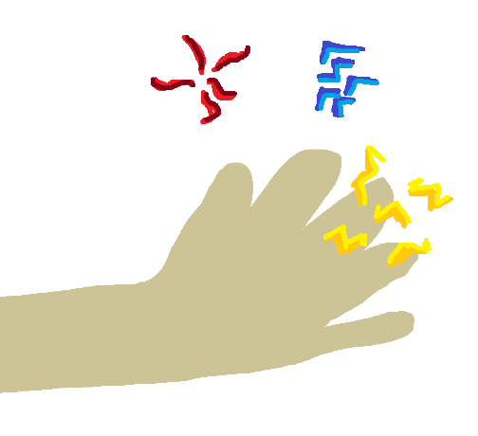
Channeling Prisma
The Soul Given Shape
“The breastplate glows a bright yellow hue.
‘Yellow!? No, this work should be grounded in fabrication. It needs to be sturdy. Flow and change have no place here’, cries the Artificer.
‘Let me see if I can pull it back toward blue—'
The breastplate glows an even brighter yellow…”
The art of using and manipulating Prisma – both external and from within – is known as Channeling.
The term is a very broad umbrella that covers a wide range of applications such as spellcasting, artifice, alchemy, capture, storage, and even meditation. Prisma can be channeled using the self as a vessel, or through external tools and foci depending on the context and goals. If Prisma is moved, manipulated, imbued, or spent – it is being channeled.
However, regardless of context, there are several fundamental principles and technologies used in the process of channeling Prisma – the most primitive and important of these being Lenses

Lenses
Prisma is stained by the intent and biases of everything it comes into contact with as it descends from the cosmos. This holds true in the context of both mind and matter, as it has been observed that societies who become enthralled by commerce and seafaring, even in a naturally fabric environment, will stain the world around them yellow over decades and centuries.
But several staining methods prove to be the most effective in both potency and efficiency, and very few match up in these regards when compared to Tidestone, Cinderstone, and Loamstone. Prisma that comes into contact with rock in any of these classifications is tinted immediately and clearly – and natural deposits are always found alongside large and dense pockets of prisma.
Each of these stones – the Noble Ores* (author’s note: name pending) – can be refined into glass and metal where these properties still hold true. The metals are then often used as the foundation of artifice imbued with Prisma, and the glass is shaped into lenses – translucent disks that stain any Prima flowing through them.

Red, Blue, and Yellow Lenses of this nature are called Basic Lenses
Beyond the soul itself, this is the most widely used method of staining Prisma in a controlled manner.
The process of staining Prima into Prisma is never 100% efficient due to the underlying principles of Prima itself. Prima is used as the energy source of the conversion process itself, and so, small discharges of red and yellow will be observed when staining Prima from pure white to a deep blue. This Generally Occurs in a Ratio of 3:2, where 3 units of Prima generally create 2 units of Prisma. Then, there is generally a 2:1 ratio when Prisma is wholly stained from one color to another. Basic Lenses, consequently, convert 3 units of Prima into 2 units of Lower Order Prisma, or 2 units of Prisma into 1 unit of another type of Prisma. This can be written shorthand as a 3:2:1 ratio, and is considered the ideal for Prismatic Conversion – and is widely believed to be the reason Lower Order Domains are considered fundamental in the first place.
Examples of Basic Lens Channeling:
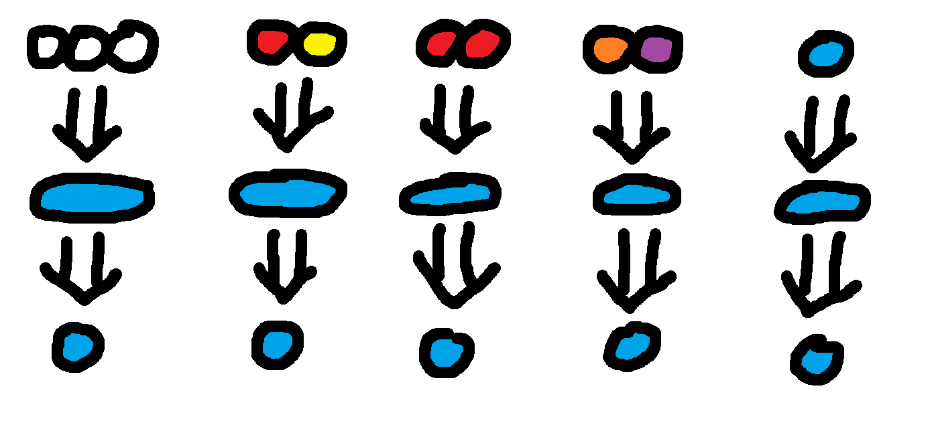
Tidestone, Cinderstone, and Loamstone have no abundant analogs representing the Higher Order Prismatic Domains. Thus, Animated, Fortified, and Invigorated Lenses most commonly are formed by combining Basic Lenses into Composite Lenses - where multiple Basic Lenses are stacked on top of one another to create a blend.

Composite Lenses, on virtue of staining twice in quick succession, have a pricier ratio of 6:1, where 6 units of Prima can be stained into 1 unit of Higher Order Prisma. Then, a 4:1 ratio where Lower-Order Prisma is stained into a single Higher-Order Variant. This is shorthanded as a 6:4:1 ratio – and serves as the main reason Higher-Order Prisma is considered more valuable and advanced.
Modern innovations on Composite Lens, however, allow channelers to somewhat circumvent the steep cost by swiveling Basic Lenses between two chambers to account for a variety of inputs – drastically increasing efficiency at scale. This means that attempting to create Green Prisma with 1 Blue and 2 Red units of input allows the channeler to direct the Blue Prisma through the Blue Lens unaffected and route the Red Prisma through the Yellow Lens for a 2:1 conversion; allowing for a 3:1 conversion instead of a 4:1 conversion. This is called a Semi-Balanced Stain
It is also worth noting that putting both of the necessary Lower Order Prisma into a Composite Lens - Red and Blue Prisma into a Purple composite lens, for example - is considered a Perfectly Balanced Stain, or simply a Balanced Stain and has a 2:1 ratio.

Examples of Composite Lens Channeling:
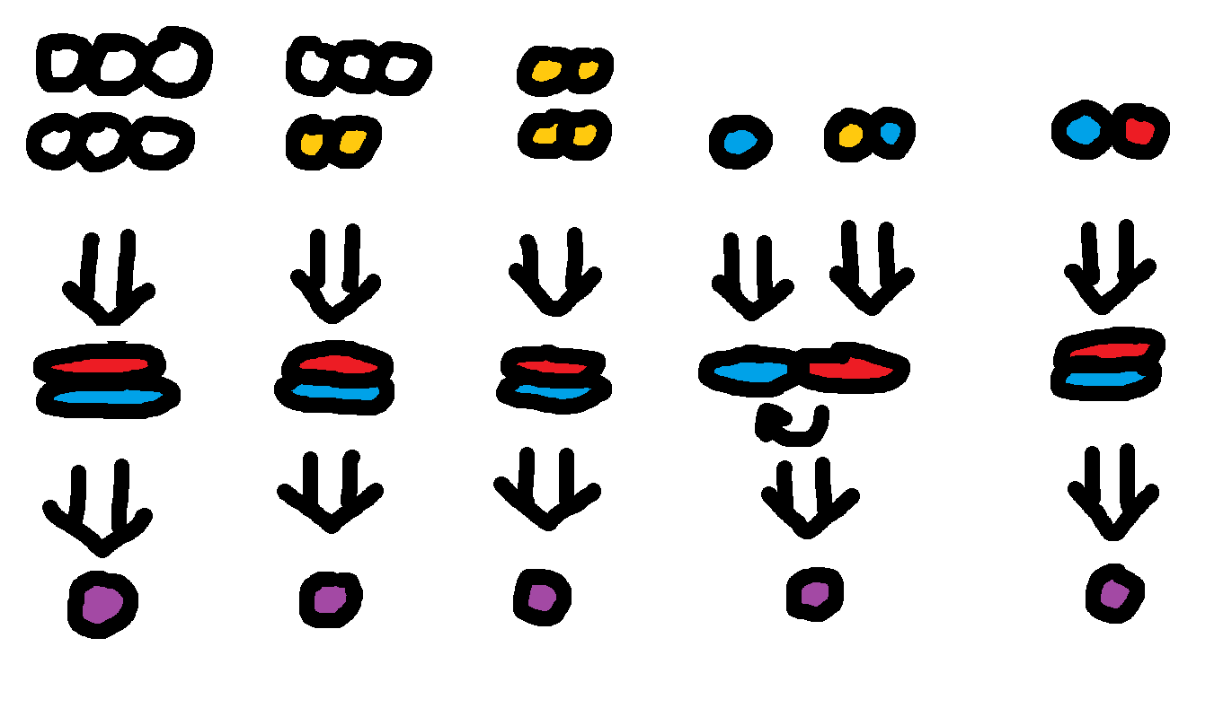

Note that Advanced Lenses exist – allowing for a clean 3:2:1 conversion ratio into and function the same way as Basic Order Lenses for Higher Order Prismatic Domains, but the refinement process to create the materials necessary is extremely rare and closely guarded by very old orders of Artificers; thus, these lenses are rare and highly sought after.

The third type of Lens is a Channeling Matrix, also known as a Specialist Lens

A Channeling Matrix consists of three Basic Lenses layered on top of each other with a single swivel allowing the user to directly control the ratio of each color.
This allows a channeler to access any of the conversions possible across all six Basic and Composite Lens Variants. Even more notably, Channeling Matrices allow for the channeling of Special Order Prisma through Balanced Stains or proper lens alignment. To cast a Sylvus Spell, for example, a Caster could either put 1 unit of Fortified Prisma and 1 unit of Fabric Prisma through the entire Matrix as a Balanced Stain, or 5 units of any color through a configuration where 100% of the Blue Lens and 67% of the Yellow Lens swiveled inward.

Examples of Channeling Matrix Channeling:
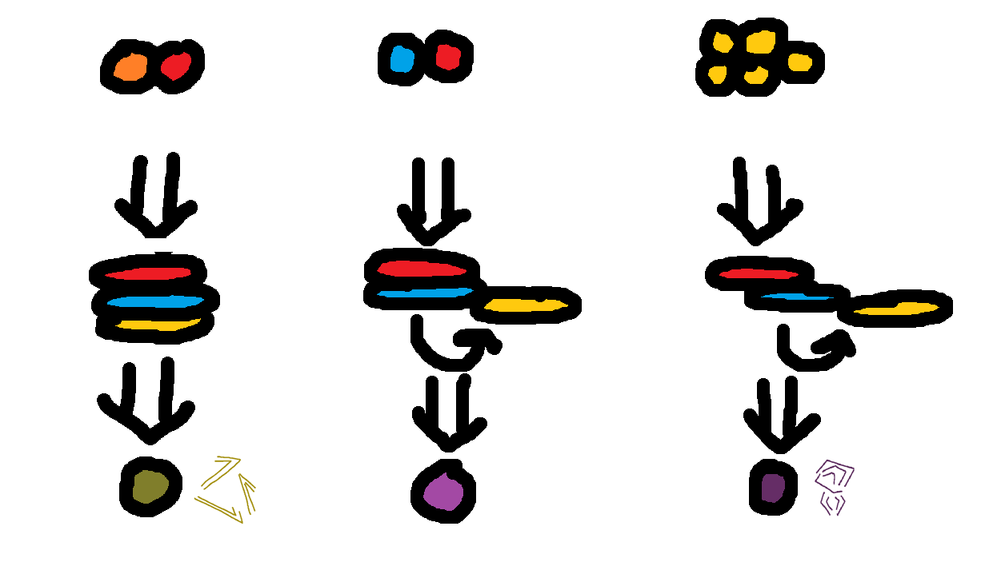

Finally, a Channeling Matrix or a Composite Lens can have the swivel removed and be soldered into a particular configuration to form a Suspended Lens; used to perform a Pre-Balanced Stain for a single precise color of Prisma

Practical Uses for Each Type of Lens
Each type of lens has several different use-cases, and any successful channeler will have all of them in their toolkit depending on the scenario.
Basic Lenses (and highly sought-after Advanced Lenses) are portable, reliable and predictable – and in the case of Basic Lenses, cheap. An Alchemist or Artificer will always want a trio of Basic Lenses on hand for an easy palette of Lower Order Prisma to work off as a foundation. Mass Prisma Transport and Storage also tend to work off of Basic Lenses; either staining massive swathes of Prima collected from the skies or allowing purchasers such as construction companies easy access to ad-hoc Blue Prisma. Artifice inlaid with Basic Lenses is often single-purpose; a gun that shoots Morphic yellow bolts or a hammer that uses deep blue prisma to Fabricate crude structures out of the ground.
Composite Lenses are used in much the same way – and Higher-Order Channelers will often carry a lens of their preferred Domain to reliably channel that color of Prisma. An Alchemist favoring Blue and Red Prisma, for example, will keep a Purple Composite Lens handy to brew potions imbued with Invigorated Prisma. Artifice inlaid with Composite Lenses tends to be dynamic-yet-bounded – for example, an Orange Composite Lens enables a breastplate to take on Morphic, Animated, and Entropic properties with the mental overhead of swapping the proper basic lenses in and out.
Channeling Matrices are the most dynamic and flexible but require manual intervention by nature. As such, they are most commonly held on one’s person, and it is considered a rite of passage for a Channeler to be granted their first Matrix. It’s trendy for Channeling Matrices to be inlaid into personal effects such as necklaces or gloves – often passed down through families over the years, subtly stained in the colors of former wielders. When deeply pronounced, these Residual Stains will often grant secondary effects to any spells cast through these Matrices. The heir to a legacy of powerful Sylvus Druids with a Green-Tinted Matrix might find their Animated Fireballs leaving patches of grass in their wake.
Artifice inlaid with a Channeling Matrix is highly dynamic but demands real investment — these pieces are often made bespoke for a particular channeler or require significant training before an outsider can wield them effectively. Rather than loading traditional ammunition, a rifle with a Channeling Matrix might require the wielder to channel their own Prisma directly into each bolt, shaping it mid-flight through active intent. This opens the door to on-the-fly imbuing: threading a bolt with Blue Prisma to leave a trackable signature on the target or biting it with Red to layer a debuffing rot that lingers past the initial impact — effects no pre-loaded reservoir weapon could produce, because they require the channeler's live Prisma rather than a fixed internal charge.
Finally, Suspended Lenses are used in the exact opposite scenario, and are highly static in pursuit of a singular, complex functionality. Gear with a focus on casting specific Special Order spells – such as Sylvus, Vitus, and Kinetus domains – require a very delicate Stain to accomplish properly. Outside of extremely accomplished and specialized channelers who instinctively know that a specific Kinetus spell might require 60% Yellow 30% Red and 10% Blue Prisma and have the muscle memory to do so in the heat of battle, the large majority of channelers would experience kickback in such a high-pressure situation. Thus, it is very common to meticulously balance out the Stain in a controlled environment, create a piece of equipment in which to embed the Channeling Matrix, and solder the Matrix into a Suspended Lens that allows the Artifact to reliably produce said effect.
Though plenty of other innovations and alternative spins on the concept exist, these lenses form the foundation of Prismatic Staining.

Storing and Measuring Prima
Prima up until this point has been described in arbitrary units. With basic lenses, 3 units of Unstained Prima is Stained into 2 units of Lower-Order Prisma, and 2 units of Lower-Order Prisma can be stained into singular unit of Lower-Order Prisma. The arithmetic holds true at any scale, so this is fine – but there is, in fact, a standardized unit of measurement that applies to Prima and Prisma alike that spellcraft, alchemy, and artifice are built around. To understand exactly how much Prisma this is, let’s first go over the fundamentals of storage and transport.
Prima is largely immaterial and cannot be contained by traditional means - be most closely comparable to plasma as a state of matter. If one were to reach out and try to grab a handful (in addition to being stained) it would be like moving one’s hand through a cloud of energetic smoke. They might feel wind and static shocks if it happened to be Morphic Prisma or a slight heat and dryness in the case of Entropic, but this is a byproduct of the Prisma’s nature rather than the body of the underlying Prima as a material entity. Additionally, Prima slowly permeates the wide majority of mundane earthly materials, so attempting to store it in a wooden or even metal box would cluster it for a time, but it would eventually seep through and set itself free into the world. Therefore, conventional means of Prismatic containment are not effective.
There are, fortunately, several materials that do appear to directly interact with Prisma – which, along with the Staining methodologies covered, complete the tools necessary to fully channel and harness the world’s Prima.
The first category of these materials can broadly be classified as Prima Conduits. Prima Conduits are materials that attract and conduct Prima to some degree. This means that a large, chunky conduit will direct the flow of Prisma across its surface – drawing it in and then ejecting it after a full loop. When conduit materials are stretched into thin wires, Prima quickly travels from one side to the other – allowing for circuits that draw Prima through lenses and toward an output. Conduit effectiveness is measured in terms of loss and potency, where loss represents the amount of Prisma shed per unit of distance and potency represents the strength through which it is drawn in. Every conduit has some degree of loss and a particular amount of potency; even the very finest, most expensive material will draw in Prisma from a certain distance and see some scattered into the wind when transferred across miles at a time, but more potent materials with lower amounts of loss lead to the most punchy and efficient devices.
The most effective conduits are cosmic in nature, found in the form of precious refined meteorite metals with negligible loss and a very high amount of potency. Worldly analogs do exist, however, to varying degrees of effectiveness. The most common of these are certain dense plant fibers from complex species of flora that exhibit qualities across all three lower-order Prismatic domains – presumably as an evolved trait to efficiently move Prisma across the stem and branches as needed. These serve as the practical baseline and have a moderate amount of loss and potency. Many Entropic societies use thin animal bones to similar effect, with higher potency and higher loss, and skilled Fortus Artificers have found ways to create synthetic conduits with minimal loss at the cost of potency.
The second category of materials can be classified as Prima Wards and behave in largely the inverse manner. Prima Wards have the curious quality of being intangible to Prima on one surface, and then powerful insulators on the other – making for effective storage devices. Wards, then, can be shaped into empty containers – passively and freely accepting Prima from without, and then trapping it within. They can also be flatted and layered on top of each other, insulator sides facing out, to create a Barrier – useful for completely blocking the flow of Prima into an area. Ward Effectiveness is defined by permeability and insulation, representing the ease of accepting Prisma on the permeable side and the strength of keeping it contained on the insulated side.
As with conduits, cosmic materials also make the most effective Wards – this case, in the form of refined meteorite glass with near full permeability and an almost imperceptible leakage. The standard worldly analog for a ward can be seen in Amber, as its unique ability to induce biological stasis seems to extend to Prima to a degree – serving to be moderately insulating and permeable when smoothed on one side. Entropic societies have found yet another natural innovation in this realm, leveraging thick animal skulls that seem to have a high permeability but a low insulation; resulting in a battery that quickly draws in passive Prima but deflates just as fast. Conversely, Fortus Artificers have figured out synthetic wards with low permeability and high insulation, allowing for durable battery that takes a while to charge passively.

Using Wards and Conduits, Artifice can be built that stores Prisma, gates it behind a hinged barrier, and directs it along a conduit through a lens to create a full circuit.

There is one more basic component of storage and transport to be aware of. As we know, conduits, when chunky, direct Prisma along their surface, and when spread thin into a wire direct Prisma along a path. But when organic, plant-derived Conduits are flattened into a surface resembling paper – we get a Prismatic Easel. Easels are notable in the sense that while they are technically a Conduit, the large surface area is actually able to be stained much like Prima itself. Directing sustained Yellow Prisma at a blank white Easel will dye the Easel itself a deep yellow over a short period of time. Prismatic Easels are extremely popular in the arts, and it’s not uncommon for adventurers to bring a flag of this material on an adventure and raise it into the atmosphere of the region’s highest peak. But perhaps the most influential way in which these have been used is to determine young adults’ exact Prismatic attunement as a rite of passage. Placing one’s hand upon a square foot of this material for several seconds while directing tremendous willpower outward will stain the easel a myriad of colors representing the internal fingerprint. A square foot of fully stained Easel also happens to be divisible into a very useful amount of Prima across all types of channeling, as the smallest spells and weakest brews will use roughly one fifth this amount. Therefore, the fundamental unit of Prisma represents one fifth of this sheet of paper and is called an Inkling of Prisma. 5 inklings are measured to a fully stained Easel, and these inklings are used to roughly approximate the ratio of one’s soul. A paper that seems to be 40% Blue, 40% Red, and 20% Yellow would result in the channeler’s soul being measured out to 2 Inklings Blue, 2 Inklings Red, and 1 Inkling of Yellow Prisma – and they would be encouraged to study in the Invigorated Domain.
The ritual of Staining the Easel is often done many times across a channeler’s lifetime, as deeply traumatic and transformative events can completely change one or even several Inklings’ colors. Deep study in a Higher Order or even Special Order Prismatic Domain can cause these Inklings to natively become one of those colors as opposed to a composite of Lower Order Inklings. A caster with a clear, naturally Purple inkling is widely regarded as a Master of Invigorated Channeling and an understanding of the domain at a deep level, and one with a natural Pink inkling is seen as a widely sought-after healer that understands Prisma at a nigh-mystical level.

The Soul as a Lens
Now, given these principles, it is also important to understand that the body itself follows many of these same guiding principles.
The body broadly acts as a sort of Ward – passively collecting Prima from the world as well as through the consumption of food and drink, and then insulating it within. This is particularly potent during periods of rest, where the body can stockpile Prima that isn’t immediately burned into energy.
The Soul is a lens, as the Prima within the body is Stained into Prisma based on the Channeler’s intent and fingerprint. By default, Prisma is stained at the ratio represented by the Staining of the Easel – where the example of somebody showing 40% Blue, 40% Red, and 20% Yellow would accumulate Prisma in exactly that ratio after a long night’s rest.
This is, of course, swayed by moment-to-moment context and intent, where this same caster might find themselves unexpectedly accumulating high amounts of yellow prisma where they might be inspired by a large feeling of flow. However, the soul fingerprint serves as an accurate baseline of what to expect on average.
Conversion principles also carry over to the soul as a lens. A channeler with 2 inklings of Yellow Prisma on hand who needs 1 inkling Blue to cast a spell would drain themselves at a ratio of 2:1.

Finally, the body acts as a potent conduit, and a skilled channeler will deftly control the flow to project it outward into evocations, cover the body in a layer of Prisma, or pour it into artifice carry with them a reservoir of Prisma that can be directed through the body with practice. These three different use-cases also define one’s preference for Body (Prisma as an extension of self), Force (Prima projected abstractly into the world), and Artifice (Prima woven into external constructs) – and define the nature of Invigorated, Animated, and Fortified channeling broadly.

While a Renowned Channeler is able to cast spells all day and a Novice Acolyte grows exhausted after one or two of those same spells, the bodies of both technically have the same carrying capacity. Deeper understanding of the self and the world unlocks higher Functional Prisma by transforming the body into a more refined Ward, Conduit, and Lens – decreasing loss and increasing the potency and efficiency of every step of the process.

